Data Structure and Algorithm

Laboratory Activity No. 4

Arrays

|  |  |
| --- | --- |
| *Submitted by:* | *Instructor:* |
| Calica, Ljay L. | Engr. Maria Rizette H. Sayo |

08, 16, 2025

# Objectives

Introduction

Array, in general, refers to an orderly arrangement of data elements. Array is a type of data structure that stores data elements in adjacent locations. Array is considered as linear data structure that stores elements of same data types. Hence, it is also called as a linear homogenous data structure.

This laboratory activity aims to implement the principles and techniques in:

* Writing algorithms using Array data structure
* Solve programming problems using dynamic memory allocation, arrays and pointers

# Methods

Jenna’s Grocery

Jenna wants to buy the following fruits and vegetables for her daily consumption. However, she needs to distinguish between fruit and vegetable, as well as calculate the sum of prices that she has to pay in total.

Problem 1: Create a class for the fruit and the vegetable classes. Each class must have a constructor, deconstructor, copy constructor and copy assignment operator. They must also have all relevant attributes (such as name, price and quantity) and functions (such as calculate sum) as presented in the problem description above.

Problem 2: Create an array GroceryList in the driver code that will contain all items in Jenna’s Grocery List. You must then access each saved instance and display all details about the items.

Problem 3: Create a function TotalSum that will calculate the sum of all objects listed in Jenna’s Grocery List.

Problem 4: Delete the Lettuce from Jenna’s GroceryList list and de-allocate the memory assigned.

# Results

This program acts as a smart grocery assistant for Jenna. It starts by creating a digital list of her items, storing each fruit and vegetable's name, price, and quantity. The items display neatly in a receipt-like table with their individual costs and categories. It automatically calculates her total spending, eliminating manual math. When Jenna changes her mind (like removing lettuce), the list updates instantly, recalculating her new total. The simple, organized layout makes grocery management effortless, combining clear information with flexible adjustments - just like real shopping, but without the hassle.

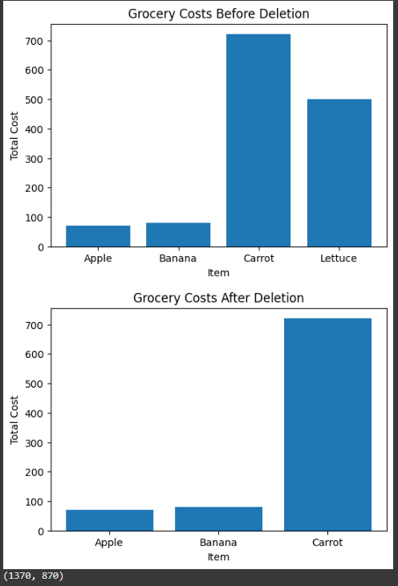

Figure 1 Screenshot of chart

**SOURCECODE**

( For Figure 1)

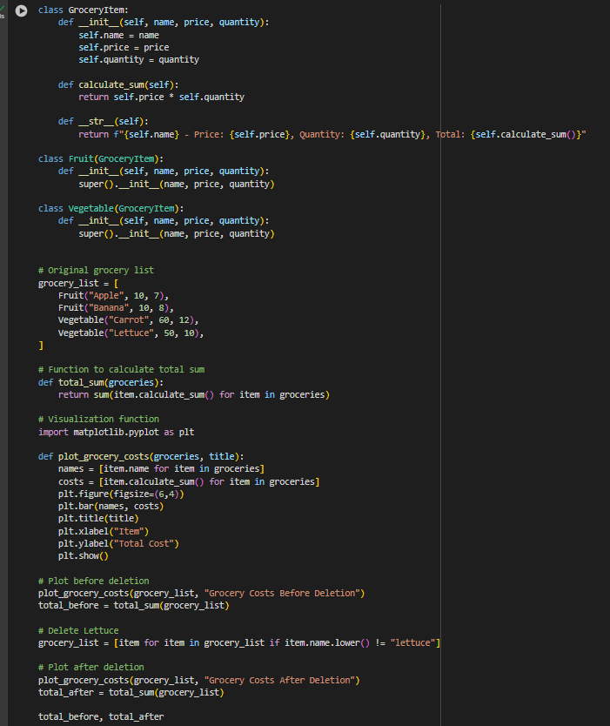

Figure 2 Screenshot of SourceCode

SOURCECODE

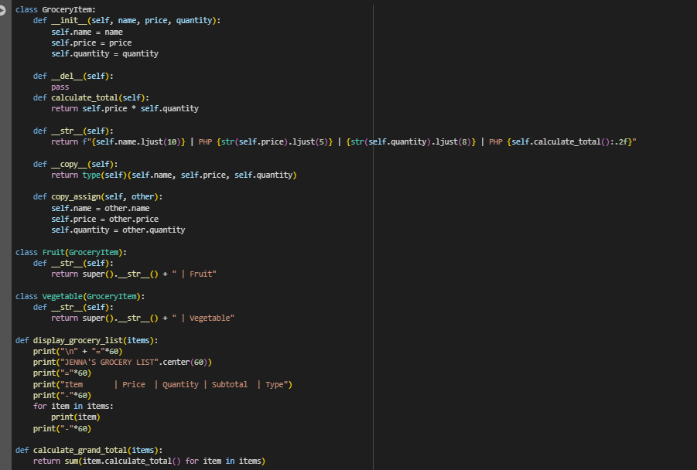

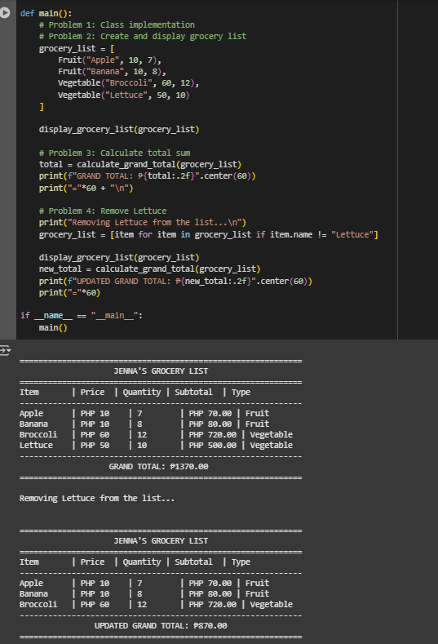

Figure 3 Screenshot of SourceCode

Algorithm

* + 1. **Initialization**: Create objects for each grocery item (fruits and vegetables) and store them in an array.
    2. **Display**: Present the items in a tabular format with their details.
    3. **Summary Calculation**: Compute the total cost and count of items.
    4. **Modification**: Remove a specific item (Lettuce) from the list.
    5. **Updated Display**: Show the modified list and recalculated summary.

**FLOWCHART**

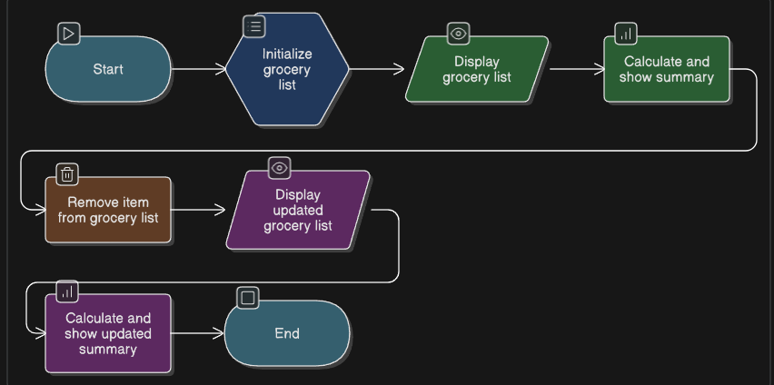

Figure 2 Screenshot of Flowchart

**FLOWCHART**

1. **Start & Initialization** (Oval & Parallelogram)
2. The flowchart **begins** with a Start symbol (oval), indicating the program’s entry point.
3. Next, a **Process** symbol (rectangle) represents the initialization of grocery items (fruits and vegetables).
4. **Display** **List** (Input/Output - Parallelogram)
5. **Calculate Total** (Process - Rectangle)
6. **Modificatio**n (Process - Rectangle)
7. **Updated Display** & Summary (Input/Output - Parallelogram)
8. **End** (Oval)

# Conclusion

In this grocery list program, is like a helpful digital assistant it keeps the information organized, does the math for her, and adjusts on the code when she changes her mind. By breaking down each step clearly, from creating the list to updating it, the program makes managing groceries simple and make it easier to understand. It’s a practical example of how basic coding can solve everyday problems, turning what could be into something quick and effortless. As a beginner, I just appreciate efficiency, this project shows how a little structure can go a long way in making life easier.

**References**

[1] GeeksforGeeks. (2023). Arrays in Python.

<https://www.geeksforgeeks.org/python-arrays/>

[2] Nielsen, J. (2022). Table design for data presentation. Nielsen Norman Group.

<https://www.nngroup.com/articles/tables-data/>